CISCO TACTICAL CONTROLLER GUIDE

Hey there Motivator! From the creators of the CrayonEaters Series...

Tired of manually updating your routers and switches before every field op? Feeling dumb when you are typing the same commands on every device?

Don't worry, the Cisco Tactical Controller is here to save you some time and effort!

No more bending over to reach the console port of your LEM's switch. No more finding a console cable just to not have the drivers installed on your CM. Enough Powershell scripts that you don't even understand. Someone get a damn GUI!

And we got it, just fresh off the compiler for you. Lightweight, portable and easy to operate, this controller can run updates on INSTALL mode for many Cisco IOS-XE devices at once with just 2 clicks! Keep track of your devices on a nice EXCEL tracker organized by sheets for each scenario, and choose whether to push and retrieve data from devices, or run updates on them. Run this app in any MCEN laptop, in any CM, in your personal gaming computer,... anywhere, at any time, in any enclave.

In today's battlefield, DNAC is not tactical and ANSIBLE is impractical. Don't even think about TERRAFORM. When you are in the middle of the jungle operating a LAN it is humid, it is hot, and suddenly DCO complains about the version of the switches being outdated, causing your leadership to crash out. The last you want to think about is HashiCorp language while your Gunny is yelling at you to get the updates done faster. Dominate this tactical tool and become part of the next generation of network administrators. Stop working hard, start working smart.



1. Unzip the application folder.

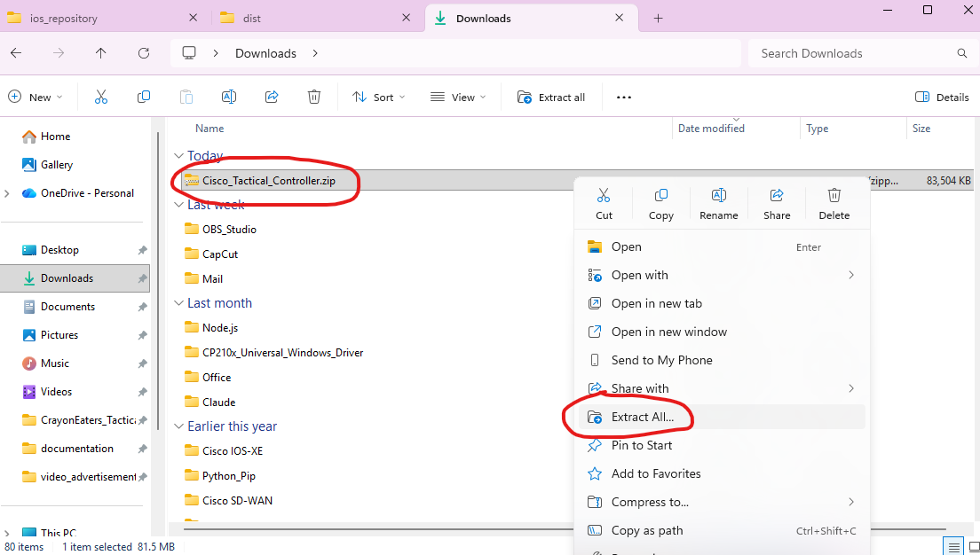

2. Open the EXCEL file inside the folder: once we open the EXCEL file, we will see some samples of EXCEL sheets. These samples have been made so we can copy the tables and paste them on a new sheet with our custom parameters.

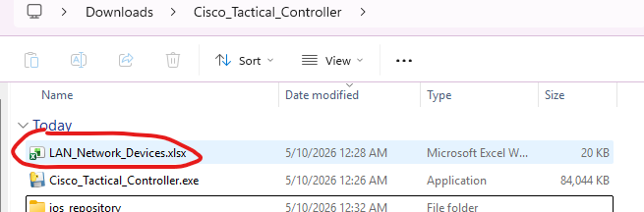

3. Create a new EXCEL sheet: the best practice is to create a new EXCEL sheet and not reuse the sample ones. We can name the new sheet based on the site code, exercise, location, …
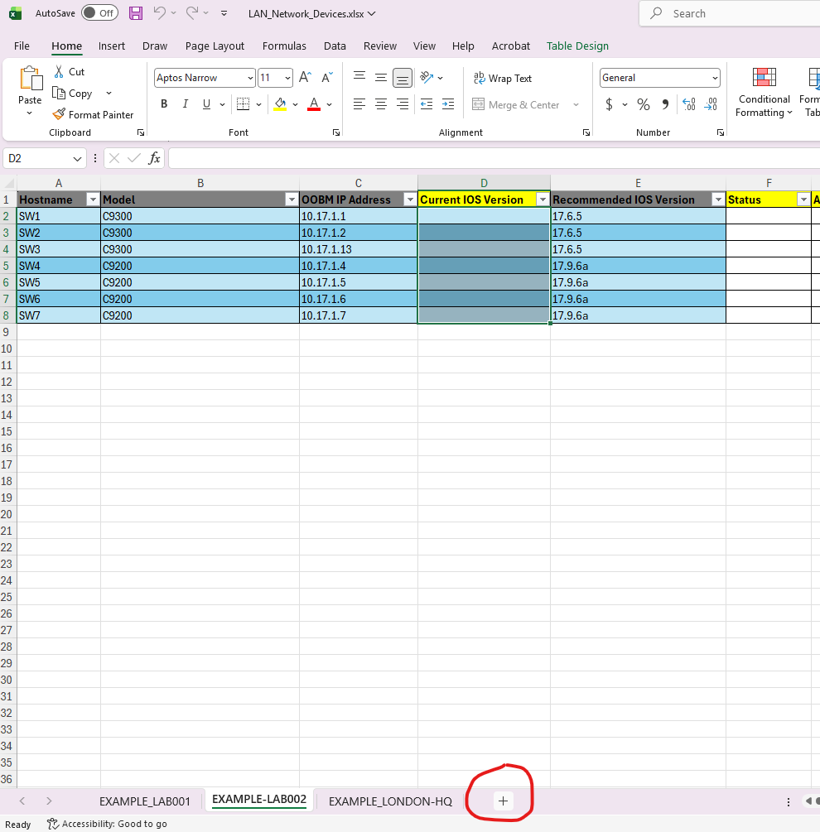

For example, a sheet called “BK26” may contain the data of the network devices of the exercise Balikatan26, and a sheet named “DARWIN” may be populated with the data of network devices located in Darwin, Australia.

4. OPTIONAL: Copy one of the tables from the sample sheets to the new sheet: this tables have been crafted with conditional formatting rules that will color the cells in relation with their dynamic content. You can also create the table from scratch, but the header names will need to match exactly the original ones.

5. Populate the table with our network data: this depends on the mode of the application that we choose to use:

In COMMAND PUSHER mode, we only need to fill the columns:

- Hostname
- OOBM IP Address
- Model

In UPDATER mode, we need to fill the columns:

- Hostname
- OOBM IP Address
- Model
- Recommended IOS Version (the number of the new IOS version we want to install)

Remember that the ‘Model’ column value has to match EXACTLY the name of the folder in the “ios_repository” parent folder.

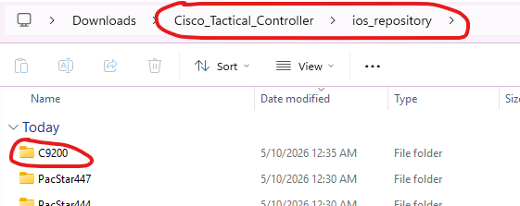
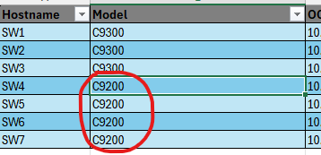

6. Save the EXCEL file and close it.

7. Only for UPDATER mode: if we want to use UPDATER mode, we will need to download the IOS image files from Cisco Software Central and save the files in the correspondent folder under the “ios_repository” parent folder. If the folder for the model does not exists, we can create it.

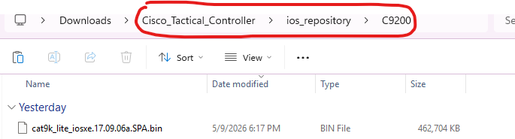

8. Open the application executable file: simply double click on it and the GUI will pop up after a minute.

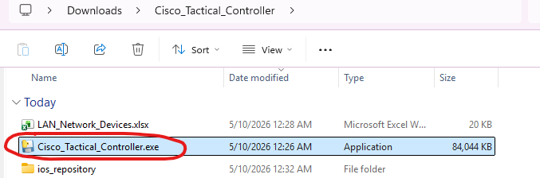

9. Start using the app! From here, everything is pretty intuitive. We included an example of each mode. To get started, we just need to type the EXCEL sheet name on the text box and click SHOW ELIGIBLE DEVICES. We will be prompted for our SSH credentials to access the network devices (for example, your FMF TG Admin account), and we can choose the application mode in the same window.

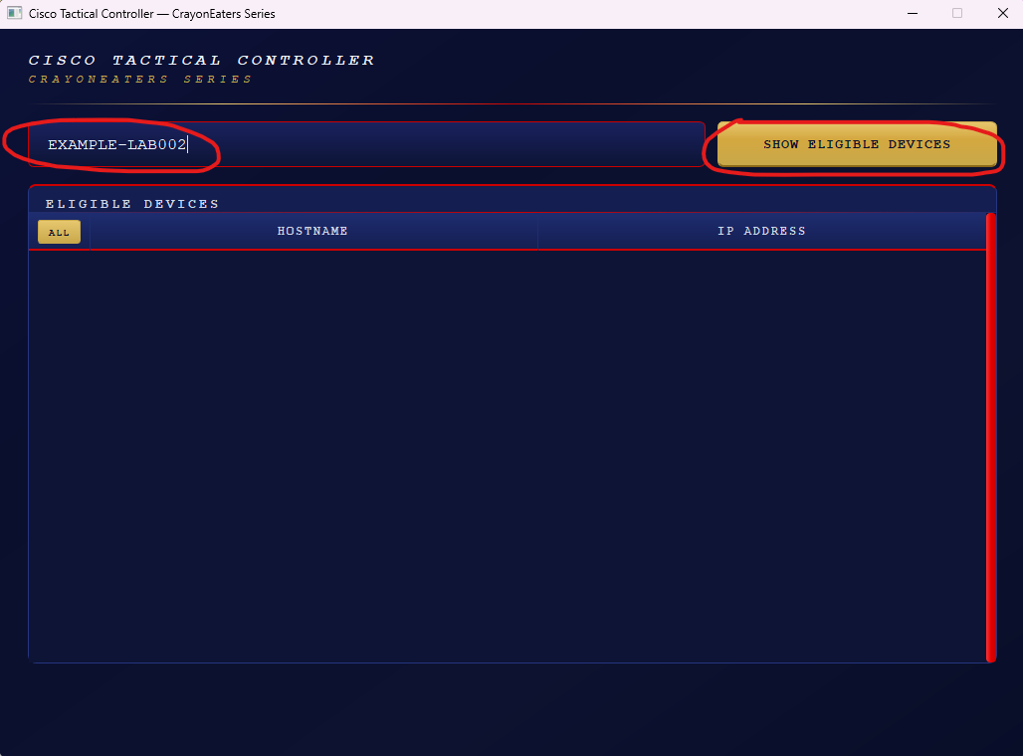

COMMAND PUSHER EXAMPLE
---------------------------------------------

First, we select the desired devices by clicking their checkbox. Then, we click PUSH COMMANDS.

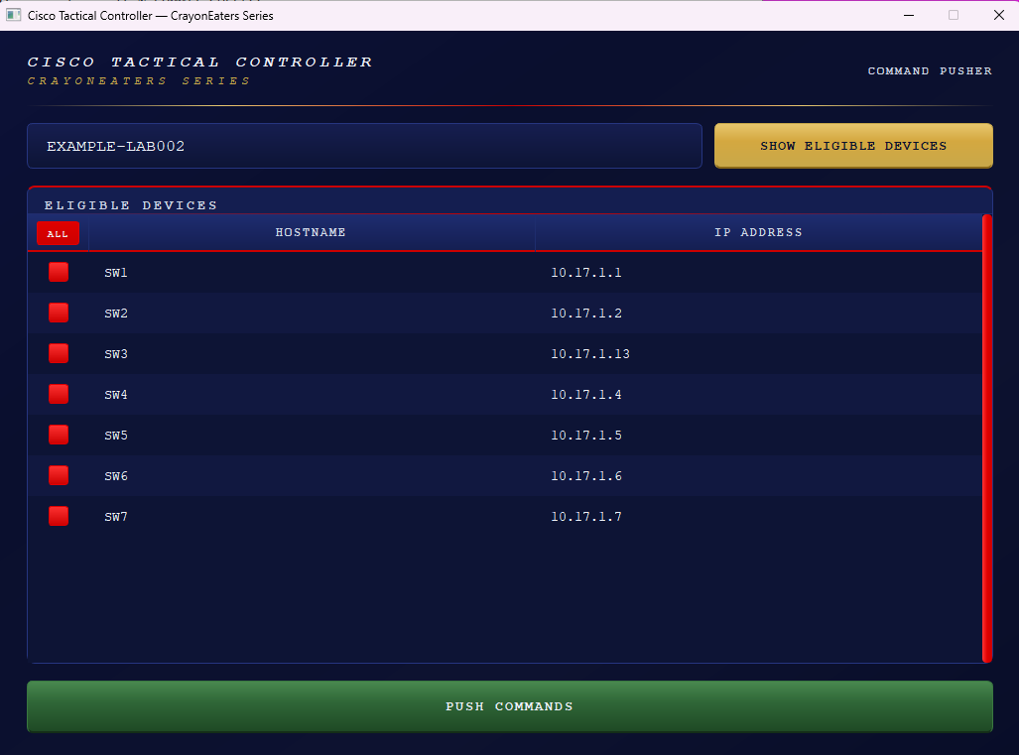

Now we need to type the commands we want to push in the text box that pops up:

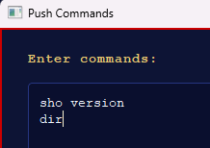

Next we push the commands. The output per device is available by clicking on each device’s name tab. The color represents the result of the push. A yellow or red color means that something went wrong, so we should check them to see what the issue is.

We can then click PUSH MORE to run more commands over the devices that we already selected, or we can close the window.

UPDATER EXAMPLE
------------------------------

First, we select the desired devices by clicking their checkbox.
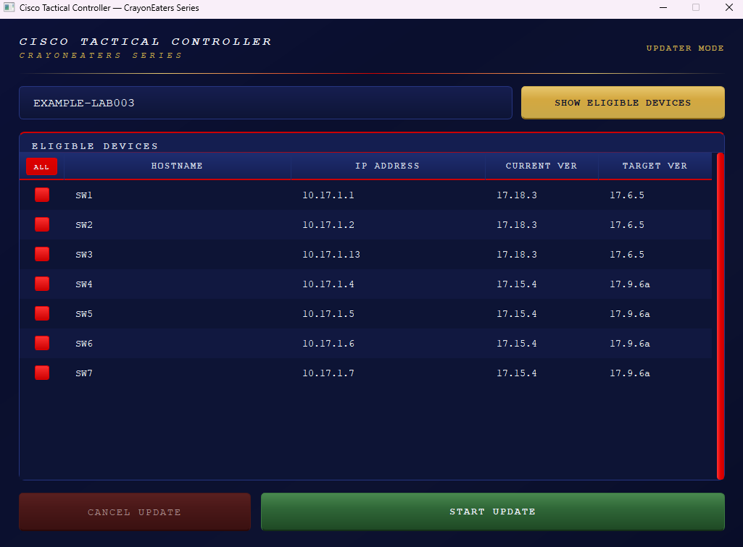

Note that the devices shown in this mode are the ones that comply with all the additional requirements for this application mode:

- SCP enabled
- RESTCONF enabled
- IOS image file present in the correspondent folder
- Enough FLASH memory space
- Recommended IOS Version different than Current IOS Version

So if we are not seeing some expected device, we should check the EXCEL table’s dynamic columns to see which requirement is not being satisfied by such device.

Then, we click START UPDATE and the entire INSTALL-MODE Upgrade process runs in an automated fashion (be aware that it is not an update in BUNDLE MODE).

We can go get some WingStop with fries and ranch and come back when the update is done. It may take a while depending on the version, file sizes, … We can also click CANCEL UPDATE if desired (only available during the SCP transfer). Be aware that canceling the update involves kicking every SSH session out of the device (clearing all VTY lines).

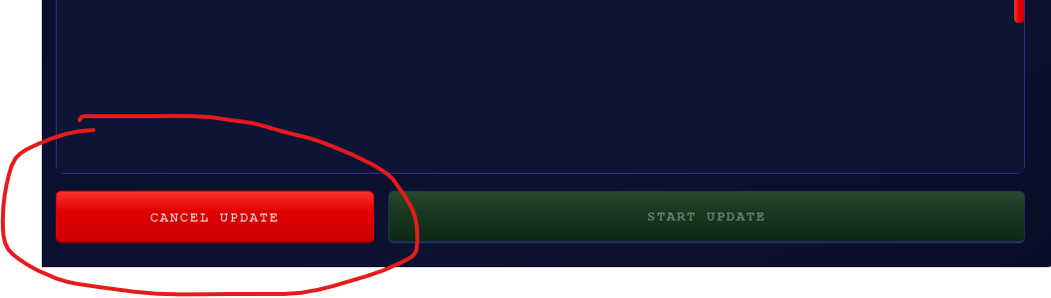

In case of errors, an error window will pop up. Do NOT open the EXCEL file during the upgrade time, otherwise it will not be dynamically populated and we will not know the results of each stage of the process for each device. However, having the EXCEL file open will not stop the upgrade process.

At the end of the upgrade, a summary window will be displayed with a count of the results. We should always open the EXCEL file and check the correspondent sheet to ensure that everything went as expected, and fix any errors that happened.

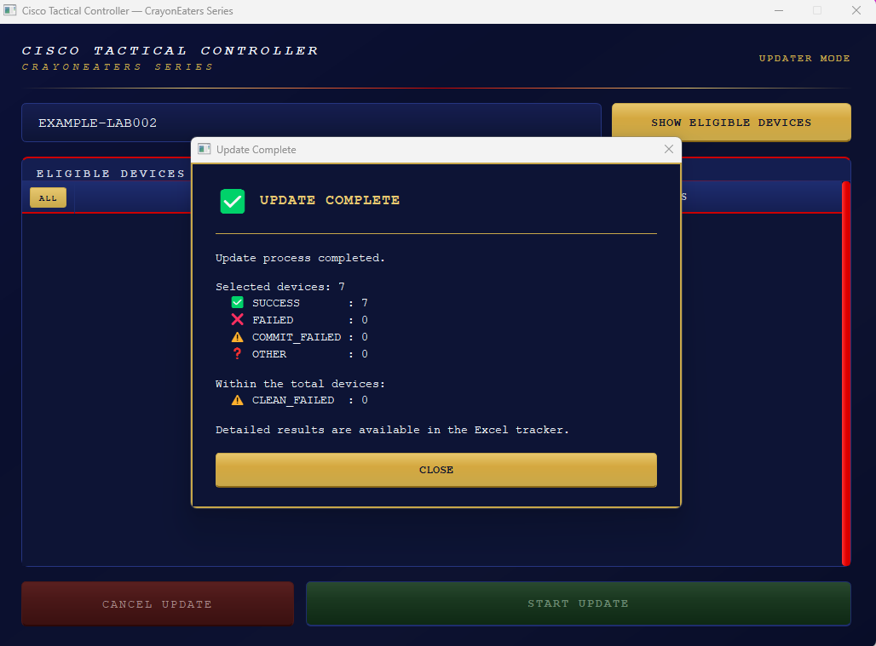

For a more detailed output of the process, the execution_logs.log file contains the application logs, listing every step and action that is taken as well as the results of it.

SUPPORT
--------------

If this application is trash and you are about to throw your laptop to the dumpster, contact me first:

- Personal Email (preferred): juanbar066@gmail.com
- Military Email: juan.gonzalezescobar@usmc.mil
- Work Email (only if my Exchange server is active): juan.gonzalezescobar@escobarsroomlab.com
- US Phone Number: 571-671-5068

- GitHub Repository link (for source code, bugs, …): https://github.com/ESCOBAR-ROOMLAB/CrayonEaters_Cisco-Tactical-Controller

